**Mathematical Foundations**

Instructions:

Please share your answers filled inline in the word document. Submit Python code and R code files wherever applicable. Mathematical calculations which are manually performed should be updated with a screenshot along with explanation in a word document.

Please ensure you update all the details:

**Name: Upadhyay Sachin Naresh**

**Batch Id: Data science_08032021**

**Topic: Mathematical Foundations**

**Problem Statements**  
Q1) Find the maximum and minimum value of the function: x^3 - 3x^2 - 9x + 12.

**Answer:**

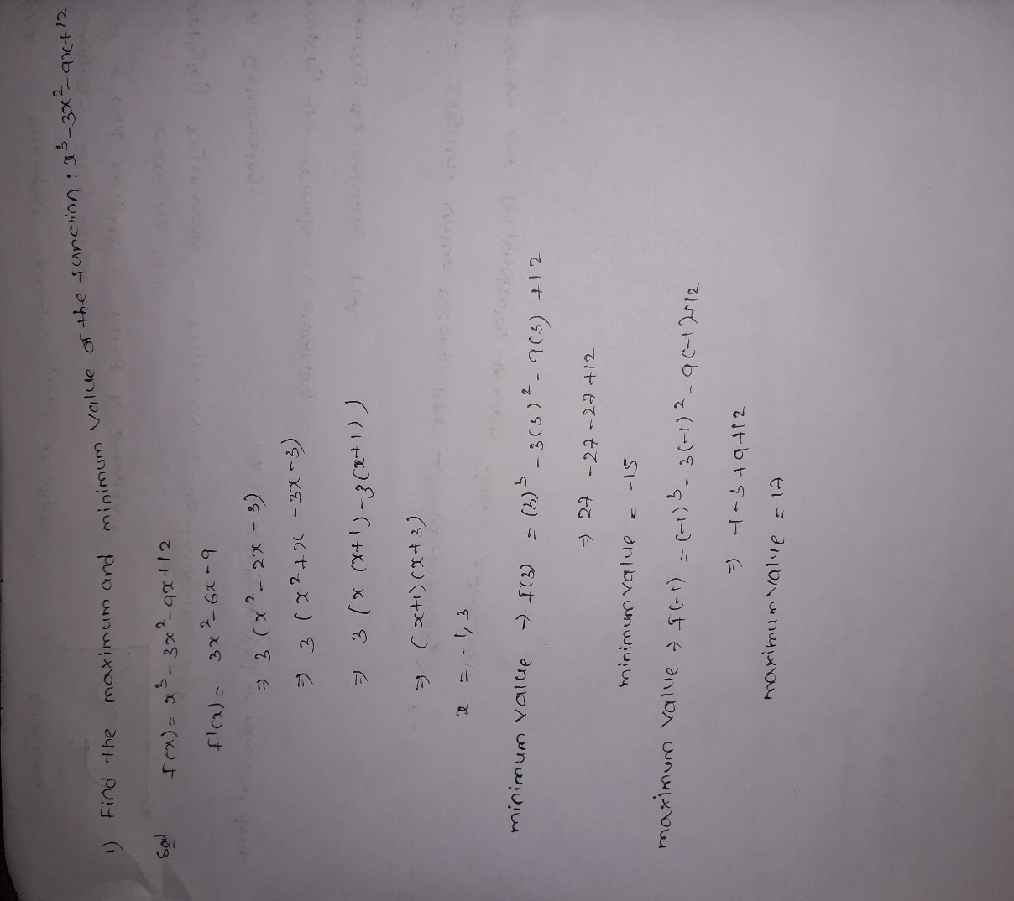

Q2) Calculate the slope and the equation of a line which passes through the points (-1, -1) (3, 8)

**Answer:**

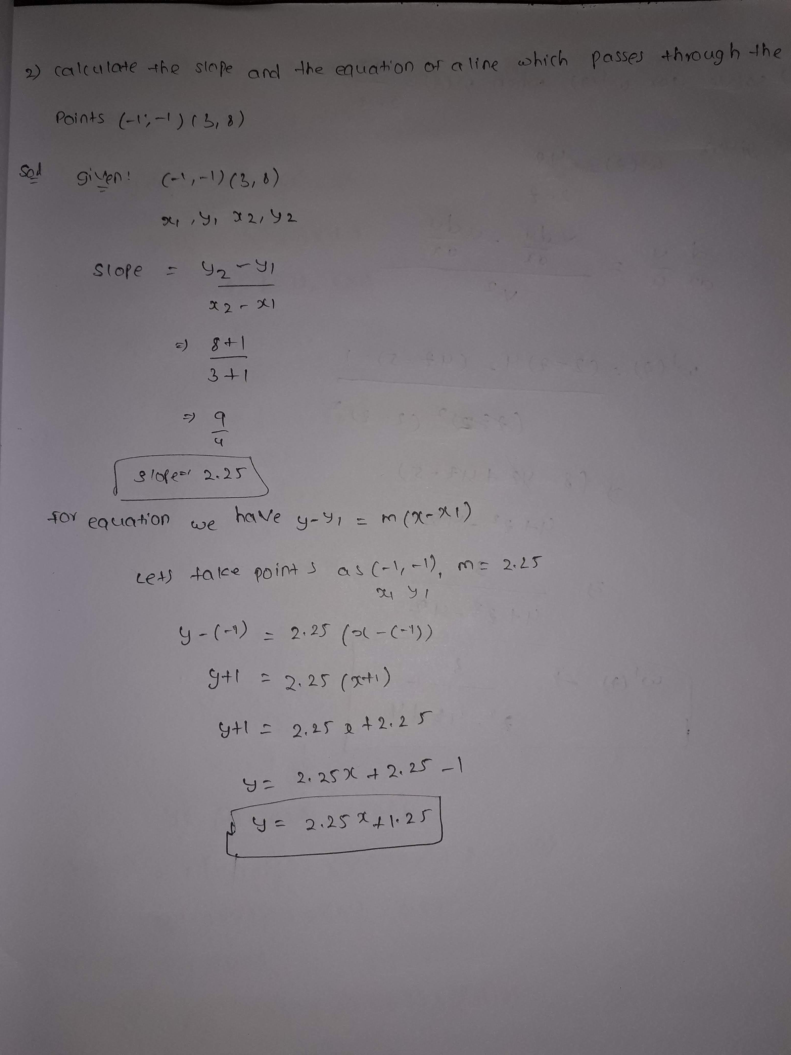

Q3) Solve for w’(z) when



**Answer:**

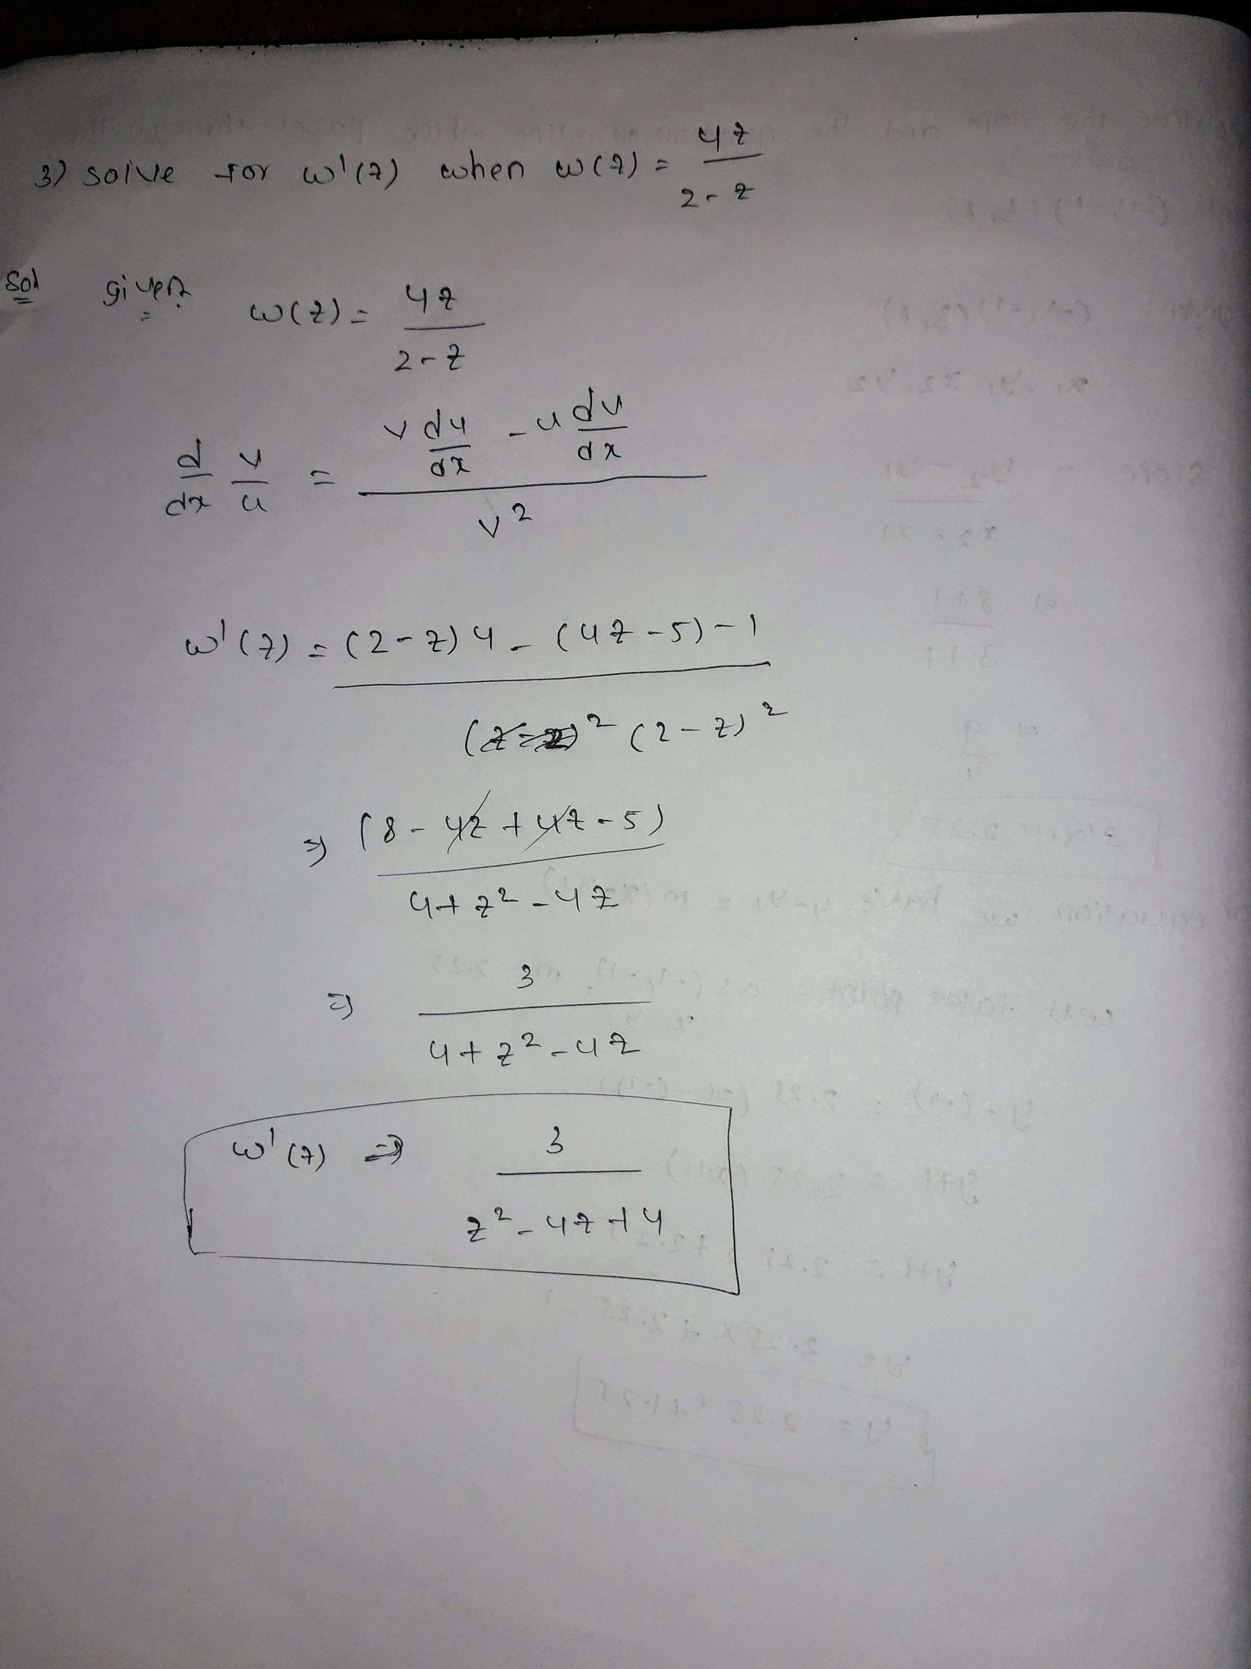

Q4) Consider Y(x)= 2x^3+6x^2+3x. Identify the critical values and verify if it gives maxima or minima.

**Answer:**

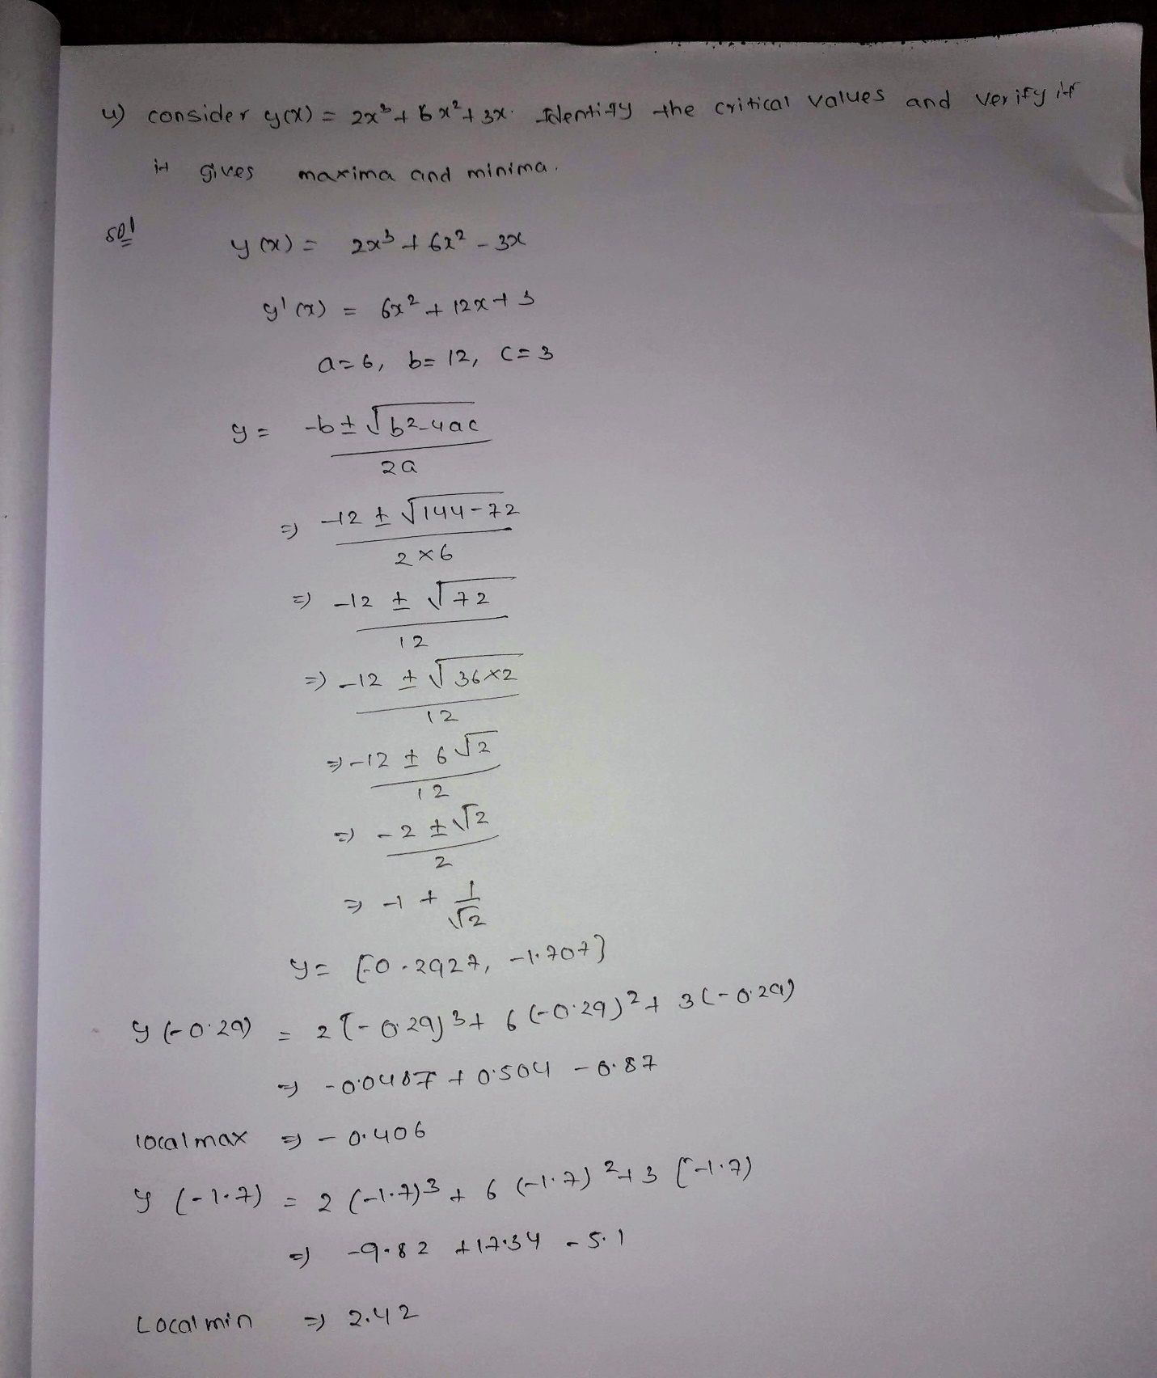

Q5) Determine the critical points and obtain relative minima or maxima of function f defined by



**ANSWER:**

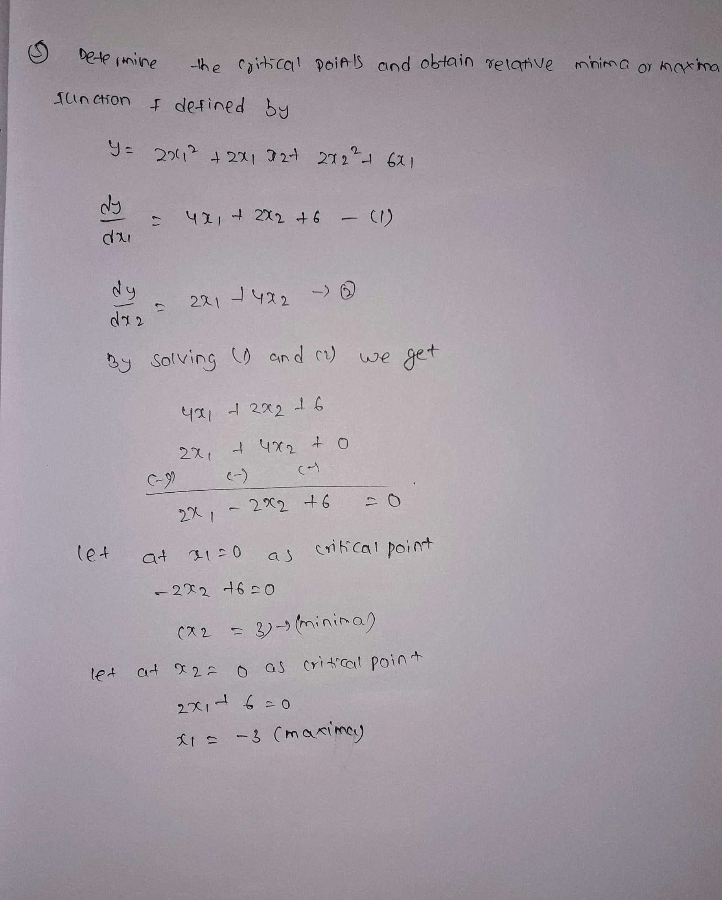

**Hints:**

For each assignment, the solution should be submitted in the below format

1. Research and Perform all possible steps for obtaining solution

2. For Statistics calculations, explanation of the solutions should be documented in black and white along with the codes. Mathematical calculations which are manually performed should be updated with a screenshot along with explanation in a word document.

Must follow these guidelines:

2.1. Be thorough with the concepts of Probability, Central Limit Theorem and Perform the

calculation stepwise

2.2. For True/False Questions, or short answer type questions explanation is must

2.3. R & Python code for Univariate Analysis (histogram, box plot, bar plots etc.) the data

distribution to be attached

3. All the codes (executable programs) should execute without errors

4. Code modularization should be followed

5. Each line of code should have comments explaining the logic and why you are using that code